Exponential UML Diagram (Low Level)

Structural UML Diagram
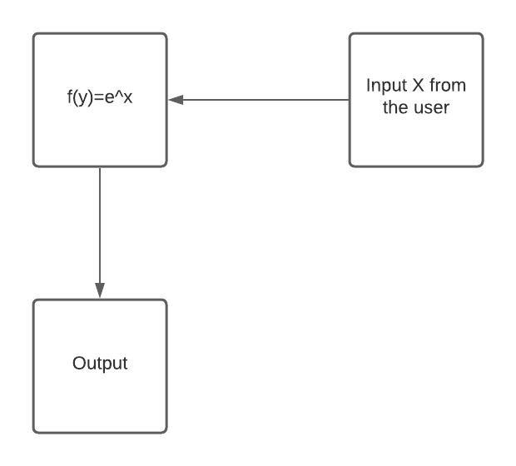

Behavioural UML Diagram

